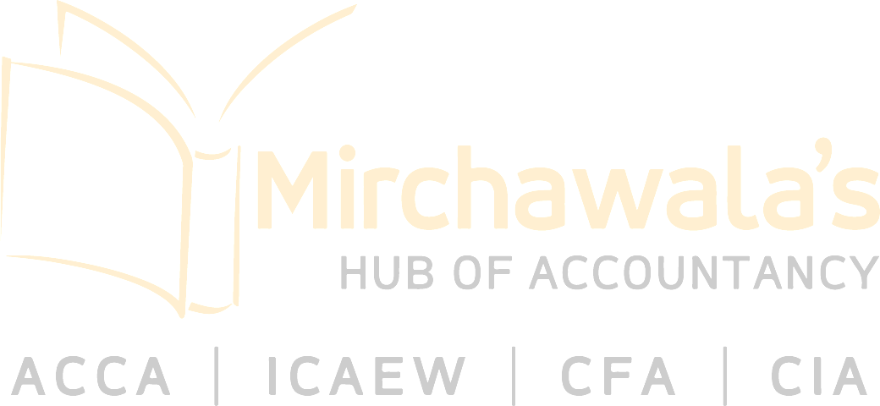
Job Description

Position Title | ACCA Trainee Program
Department | Finance
Date limit | 31st March 2024

POSITION DESCRIPTION
Meezan Bank is looking for ACCA Atleast (7 papers Cleared) for ACCA Trainee Program. Age should be 26 years or less of age on date of Application.

SALIENT FEATURES
- Lucrative Stipend will be provided to Trainees on pursuing ACCA
- Progressive Increase in Stipend on every Paper Cleared.
- Annual Increment based on performance
- Substantial Financial Assistance for Exam Fees, Annual Subscription & Study Material
- Medical and Life Takaful Coverage
- Relevant Training for Skills Development
- Study Leaves
- Pathway towards permanent employment
REQUIRED JOB SPECIFICATIONS

Required Qualification | ACCA (Atleast 7 papers Cleared)
Required Experience
REQUIRED JOB COMPETENCIES (Technical and Soft Skills)
S# | Competency | Criticality (High / Low / Medium)
1 | Bookkeeping | High
2 | QuickBooks | Medium
3 | Xero | Medium

